1.Create 5 documents



2.Create 1 document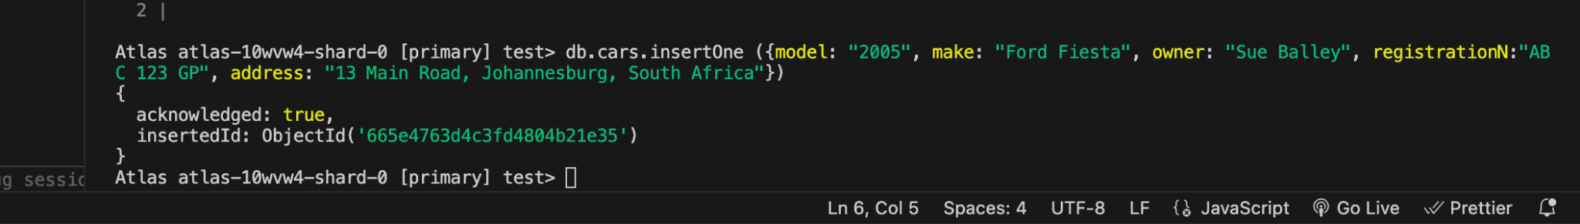

3. Display all the documents

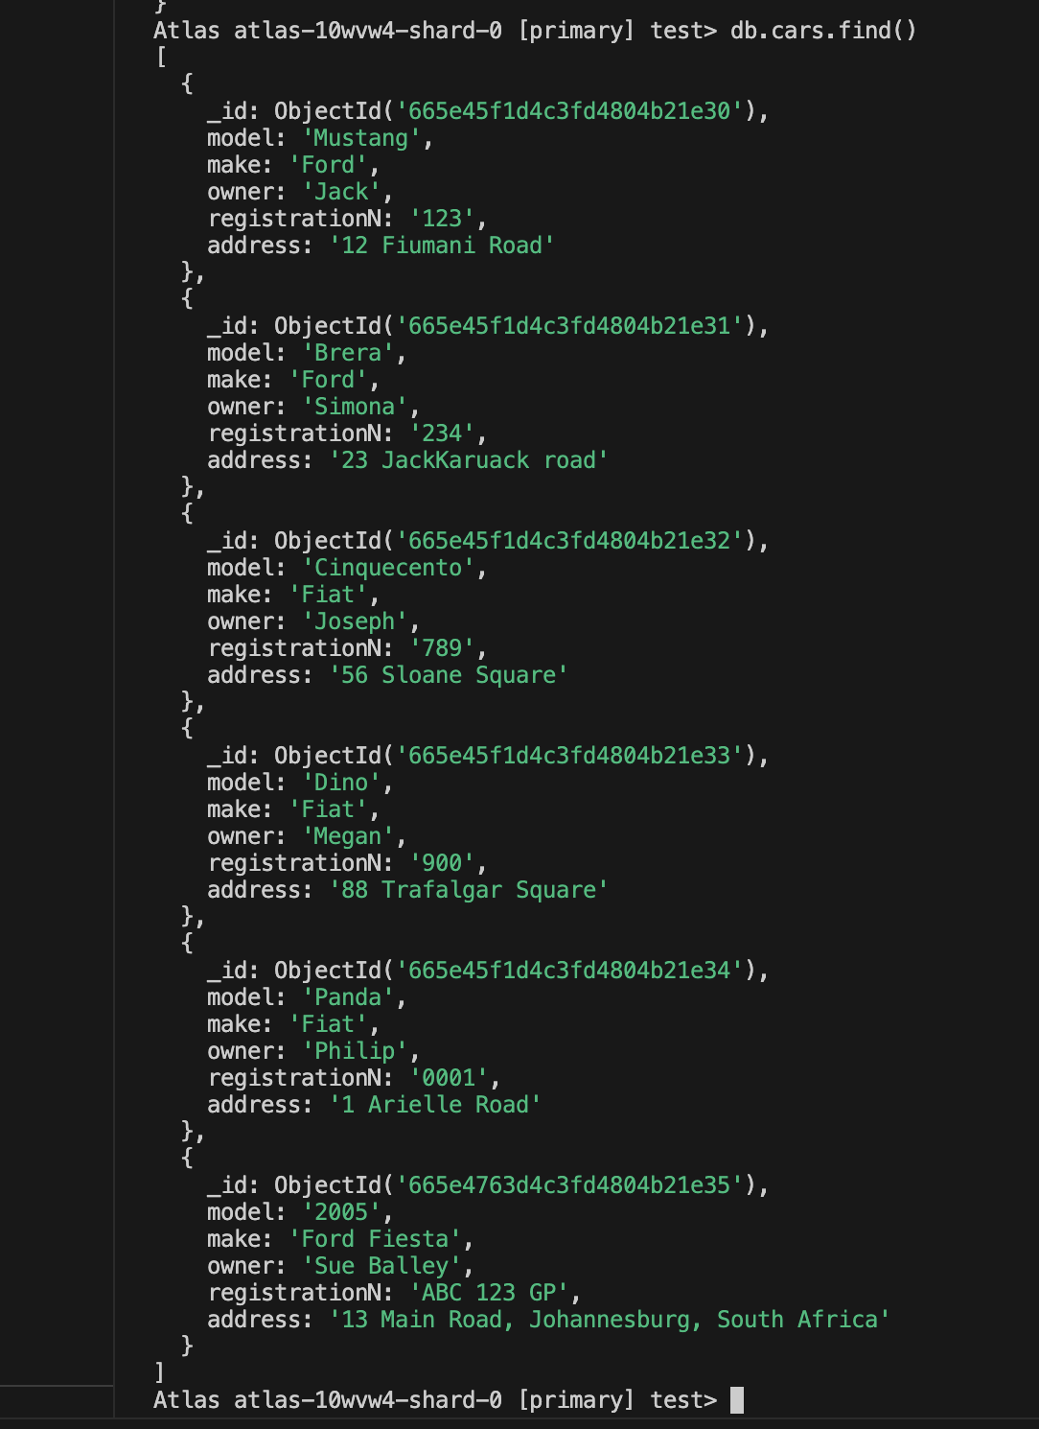

4. Update Sue Balley Address

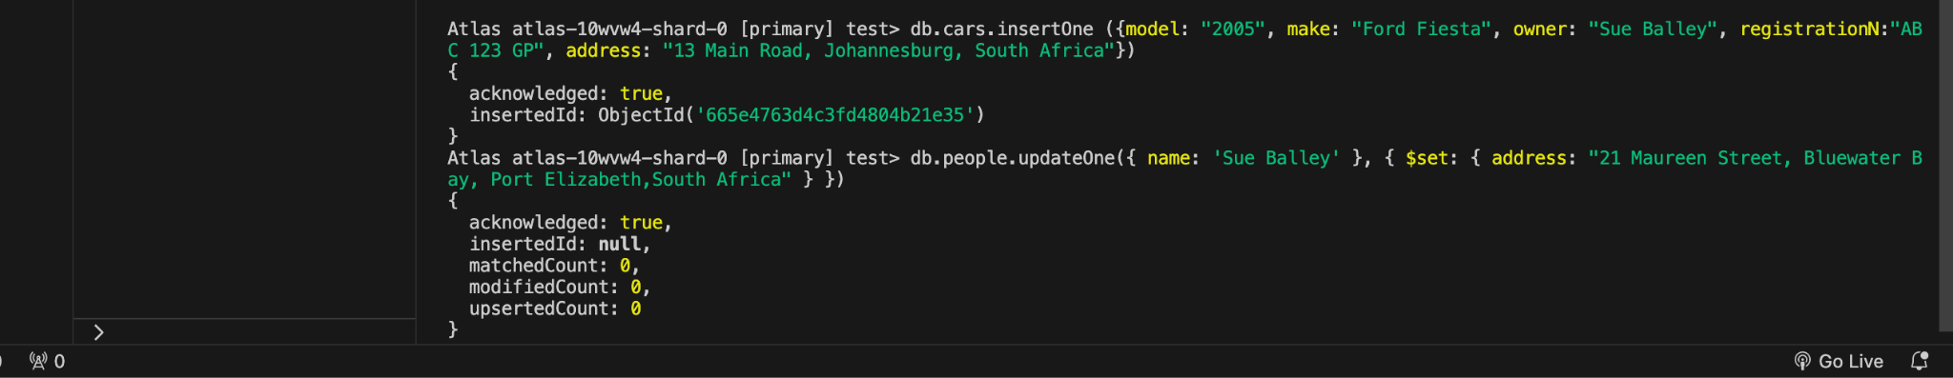

5. Update Sue’s surname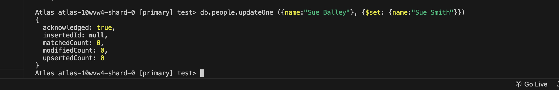

6. Displars older than 5 years

7. Create a document with the name Sue Smith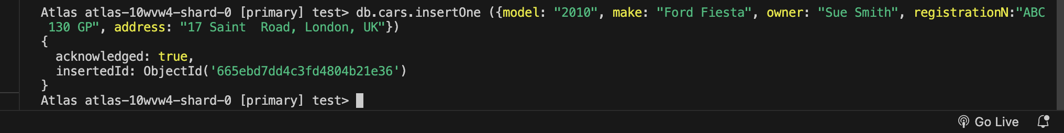

8. Delete one



10. Missing input